Nuclear Astrophysics with DRAGON at ISAC

The DRAGON Facility

Status, Commissioning and Science in 2001

I. Summary

In the twelve months since the last EEC meeting, the DRAGON facility has essentially become operational and a physics program has started. Following a program of commissioning studies and achieving several milestones, E584 received a ²¹Na radioactive beam and observed reaction products at the final focus in a commissioning run. A brief overview of the activities with emphasis on milestones since December, 2000 are provided below.

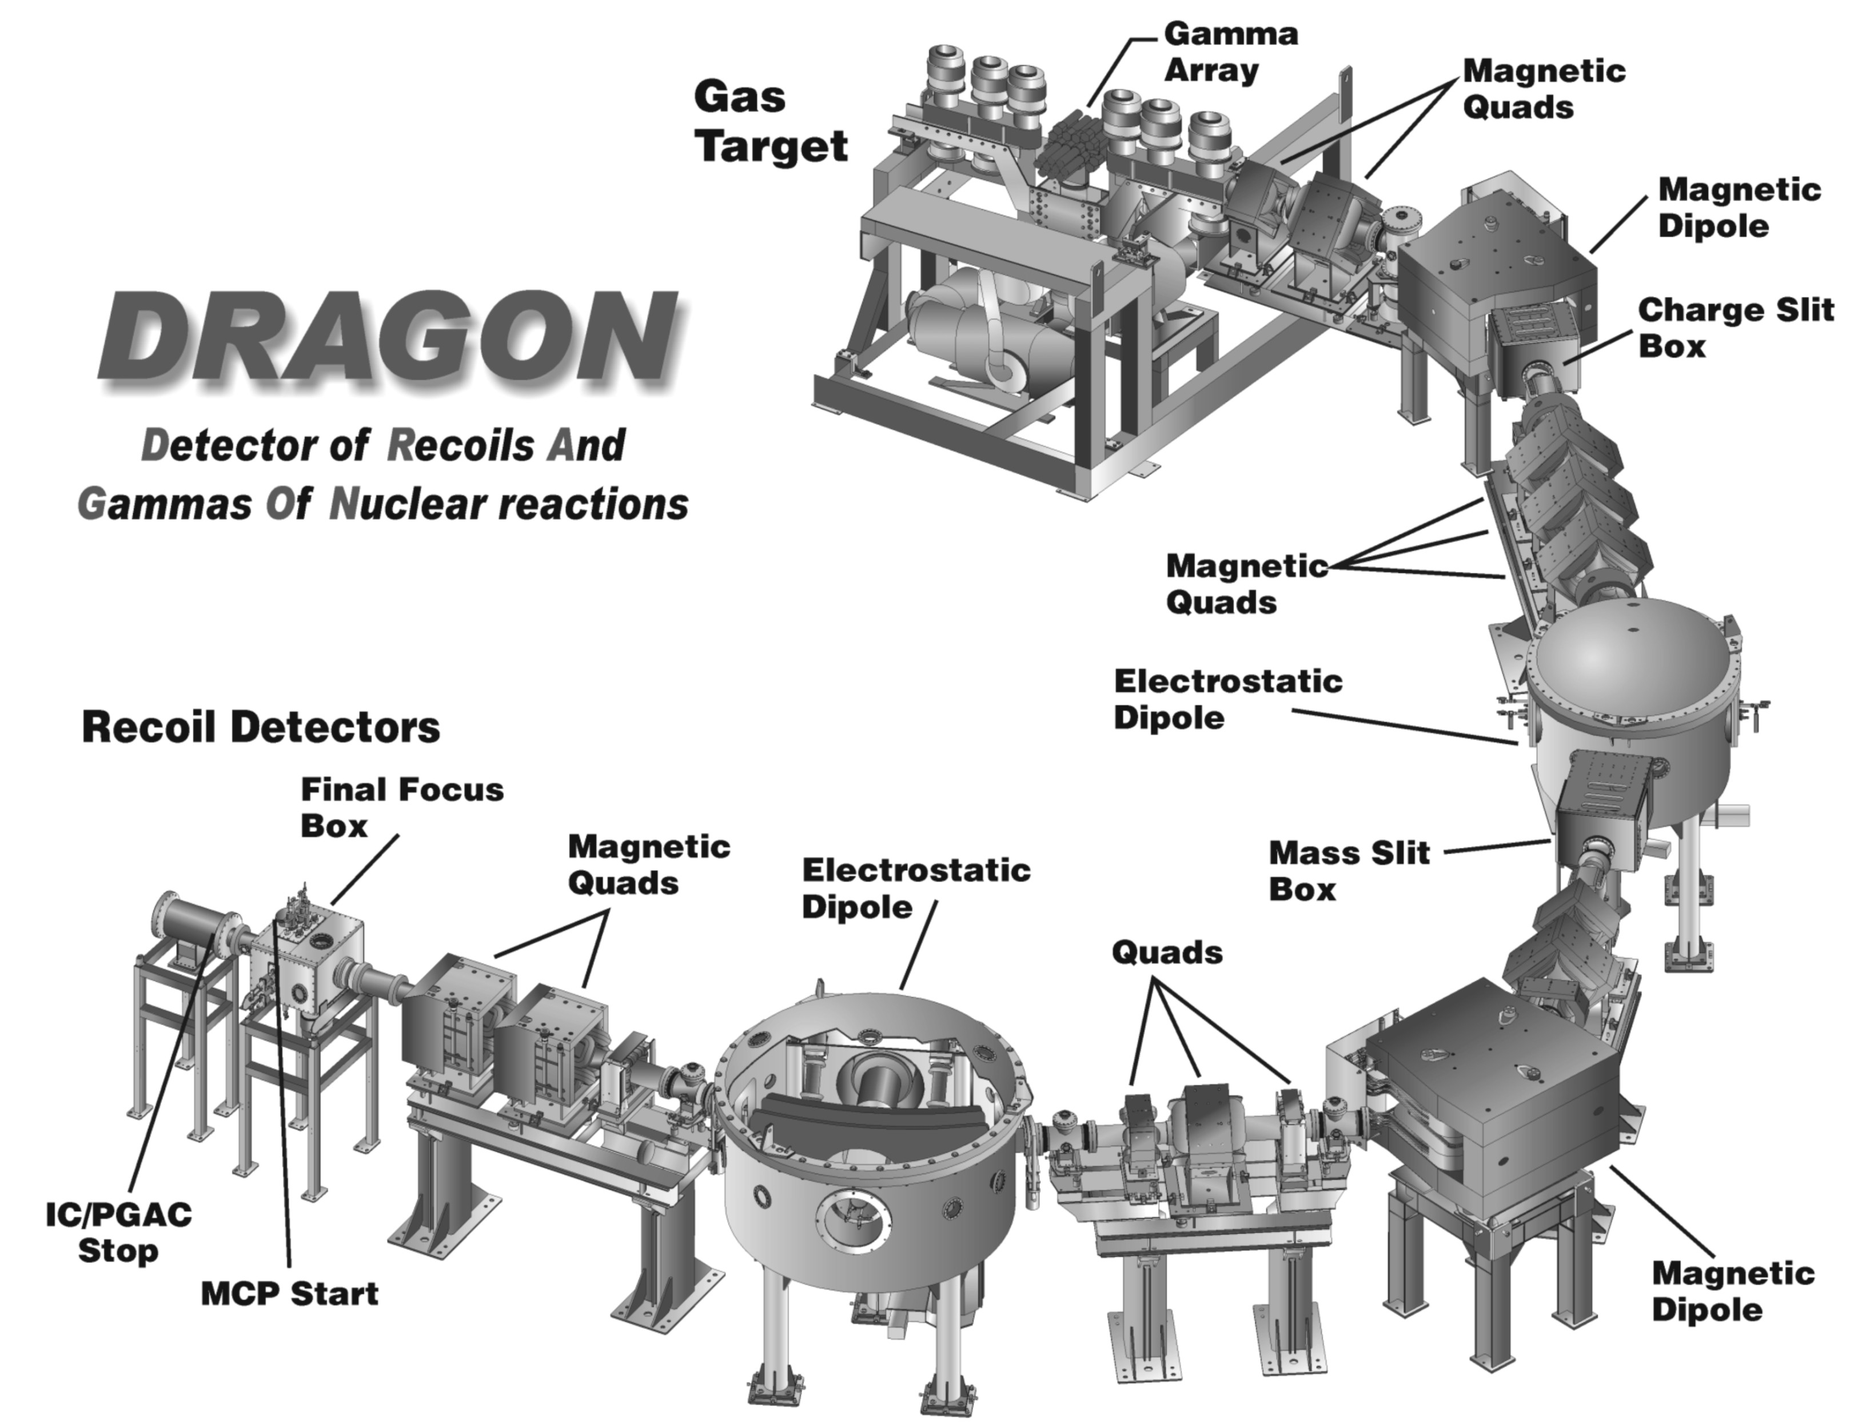

Figure 1

Latest DRAGON Layout

II. Introduction
The primary purpose of the DRAGON (Detector of Recoils And Gammas Of Nuclear reactions) is to measure the astrophysical S-factor in radiative proton and alpha capture reactions. These reactions are studies using inverse kinematics with gaseous targets of hydrogen or helium, and projectiles of radioactive heavy ions with energies from about 0.15 to 1.5 MeV/u. Such studies involving short-lived proton-rich projectiles are of interest to increasing our understanding of the processes of explosive nucleosynthesis in nova, x-ray bursts and perhaps, supernova. Funding for DRAGON was received from NSERC in three parts in 1997, 1998 and 1999. The purpose of this report is to provide a brief summary of the status of the facility, the commissioning and milestones achieved in 2001 and the initial science underway. Also included are plans for 2002.

III. The Facility
- Status of the Facility
- 1. Overview
The DRAGON facility is operational with only a few items remaining to be installed. Beams have been used into the gas target and reaction recoils observed at the final focus both with stable and radioactive beams. Figure 1 presents a graphical representation of DRAGON but other figures will be presented in the oral presentation.

- 2. Gas Target
The windowless, differentially pumped gas (hydrogen or helium) target consists of 5 Roots blowers, and 7 turbo pumps, along with a large roughing pump. It has been described in detail previously to the EEC. This system has met its design goals and is commissioned completely including the complex Control system with interlocks, and the uniquely designed clean-up trap with recirculation system. A desired pressure, e.g. 4. 5 Torr is constant for many days with minimum variation. Two Si surface barrier detectors in the target cell measure elastic scattering of the beam and as well, a small ionization chamber using the target gas is operational. A NIM publication on the gas target including operating parameters is being prepared.

Studies were performed of the charge state distributions resulting from various heavy ion projectiles with E < 1.5 MeV/u using upstream and downstream faraday cups to measure beam currents. These data form part of a M.Sc. thesis and are also being prepared for publication.

In addition, the gas target, density/pressure profile at 4.5 Torr was studied using non-resonant ¹H(¹⁵N,αγ)¹²C reaction around the 1.45 MeV/u and the Resonances at E_{cm}= 0.843 and .404 MeV. The yield of the 4.4 MeV reaction γ rays along the beam axis only depends on the gas density with the effective target interval of 1.65 cm seen by a single, Pb-collimated BGO detector. On the other side of the target a partial array of BGO detectors was also used to observe and monitor resonance position and intensity of the gamma yield. In this same set of runs the properties of the ¹⁵N ISAC beam such as energy stability, reproducibility and the energy/timing spread were also measured.

3. Electric Dipoles
Both electric dipoles were commissioned including the Control system and protect hardware, and used successfully this year. Both dipoles are conditioned up to approximately 180 kV, both manually and using the Control system. Typically the pressure in these units when isolated is <5 x 10⁻⁸ torr and ~2 x 10⁻⁷ Torr when operating with gas in the target. In ED1 the blue nylon container for the internal power supply is still being used, as the supply company was only successful in manufacturing a ceramic container for ED2. Conditioning up to higher potentials will only proceed after DRAGON is used in its first experiments for E584.

4. Electromagnetic Components and Diagnostics
All twenty magnetic elements of DRAGON have been installed, tested, commissioned and used successfully in on-line studies. NMR readouts are used with the magnetic dipoles and Hall probes are used with all quadrupoles. Remotely controllable faraday cups, slits (horizontal and vertical) and beam-centering monitors have also been installed at several locations. The optics of DRAGON was initially studied using a ¹⁴⁸Gd alpha source positioned upstream of the inner target cell, controlling the trajectory of the alpha beam at the target using a wobbler (steering) magnet, and more completely, using stable heavy ion beams. Scaling of all spectrometer elements for the purpose of tuning a particular mass/energy heavy ion beam is now performed using the Control system.

5. Controls
The EPICS based control system as originally designed had been essentially commissioned as indicated above. Changes/improvements to the final focus detector station has necessitated further changes to the control system at this location.

6. Detector Systems and Gamma Array
The BGO gamma array is fully assembled and fully operational. It has been tested both with stable beams and with radioactive beam incident onto the gas target. The support stand has also been assembled to allow for the inclusion of lead shielding to minimize room background effects, if this proves necessary. The operation and performance of the BGO gamma array with stable and radioactive beams forms the basis of a M.Sc. thesis.

Different detector systems have been tested for use at the final focus. A DSSSD (double sided, silicon strip detector) has been used during the commissioning with stable beam and with the alpha source. It was also used at the final focus for the first delivery of the ²¹Na radioactive beam. It was calibrated using low energy heavy ions from ISAC to take into account the heavy ion defect and exhibits an energy resolution of about 2.7% with lowest energy (4.6 MeV) sodium ions. The operation of the DSSSD detector system will be part of a M.Sc. thesis.

The IC/PGAC (Ionization chamber with parallel grided avalanche counter, front end) was tested successfully with low energy heavy on the ISAC beam line and also at the final focus of DRAGON. It demonstrated good response in terms of energy resolution. It has the added feature that some Z selectivity may be obtainable when running with heavy ions of the order of > 0.8 MeV/u.

The microchannel plate timing and position detector was tested off-line successfully with alpha particles but there has not been sufficient time available to test it on-line.

7. Data Acquisition System
The DAQ system is presently based upon a single CAMAC crate, using MIDAS and PAW routines. The full electronics of the system and the associated software needed to do both the particle detection acquisition with the front-end elastic monitors and final focus end detectors, and the gamma array acquisition have been tested and seem to be fully operational, ready for the experimental program.

8. Safety Hardware
DRAGON is located in a public access area and safety is of some concern. The safety hardware consists of TRIUMF radiation detectors to assess radiation fields near to the beam line, scintillation detectors to monitor the x-rays coming from the electric dipole units during commissioning, a fence surrounding DRAGON to prevent personnel access while using high intensity radioactive beams, a security lockout system to further minimize personnel access during beam operation, and 2” lead shrouds around the two vacuum chambers in which the bulk of the radioactive beam will be deposited. All of these are in place with the exception of the fence, shroud and the lockout system. These will be installed over the next weeks. Given the intensity of the ²¹Na beam (5 x 10⁸ p/s), the experiment can proceed using standard TRIUMF safety procedures to prevent personnel access to locations of high radiation fields during the experiment.

B. Commissioning Studies
1. Studies with Stable Beams (including the alpha source)
a. Optics
The optics of DRAGON were tested with both 4.18 MeV A=4 (alphas) and several stable beams. Using the DSSSD positioned initially at the charge slit box, then the mass slit box, and finally at the final focus box various projectiles were taken through DRAGON to test the observed optics against the calculated simulations with excellent agreement.

b. Reaction studies
Both the ¹H(¹⁵N,αγ)¹²C reaction and the ¹H(²¹Ne,²²Na)γ reaction were used to test components of DRAGON. The tests with the first reaction were mentioned above.

Using a 4 enA beam (5+) of ²¹Ne with an energy of 767 keV/u onto a
hydrogen gas target (~4.5 Torr), the expected resonance was observed at
E_{cm} = 732.7 keV in ²²Na both using the BGO gamma array positioned at the
windowless gas target and through observation of the recoils (~3 c/s) into a
DSSSD solid-state detector positioned at the final focus of DRAGON.
Coincidences were also observed between the 7.47 MeV prompt reaction
gammas and these recoils with an approximate efficiency of 19%
as compared to an estimated value of 16%. Measurement of the ²¹Ne(p,γ)²²Na reaction at 735 keV/u (off-resonance) demonstrated a product of beam suppression x detection efficiency of about 10¹³. Several orders of magnitude additional suppression are expected from detection of gamma rays in coincidence with the recoil ions.

2. Studies with Radioactive ²¹Na Beam
- Beam Spill
A beam of about 5 x 10⁷ particles/s with an energy of 220 keV/u were delivered to DRAGON to test beam spill both in and around the gas target into the gamma array, and also along the beam line. Studies indicated that a threshold of at least 1.5 MeV was needed in the gamma array to allow it to function properly. Spill along the beam line was measured and proved to be acceptable at a distance of 1 m. Increases spills were noted around the entrance to the target cell. The beam was taken to the DSSSD located at the final focus for calibration and resolution studies.

b. Reaction studies
Recoils of the reaction of ²¹Na with the hydrogen gas target were observed in a 5-hour experiment using the DRAGON facility. With a beam of about 5 x 10⁸ p/s of ²¹Na with an incident energy of 860 keV/u, coincidences were observed between prompt gammas in a BGO array around the target and recoiling reaction ²²Mg products observed using the DSSSD at the final focus. Approximately, 354 singles counts were observed in the DSSSD and this corresponds to an ωγ of about 30 meV as a preliminary measurement for this resonance. This state was also observed in the recent TUDA studies.

IV. Science with DRAGON
A. E584 – Measurement of the Astrophysical Rate of the ¹H(²¹Na,γ)²²Mg Reaction
Given the successful preliminary observations mentioned above during commissioning, this study is planned to commence Nov. 5, 2001 following stable beam studies using ²¹Ne. The key resonance is expected at E_{cm}= 212 keV with others at 336 (?), 460, 545 keV. The strong resonance observed above at 855 keV will be studied initially to determine the optimal operating conditions for DRAGON. Studies on and off resonance will be pursued at the lowest resonance, and others will be studied, time permitting. Status and possibly some results will be presented to the EEC. This study forms the basis of a Ph.D. thesis.

V. Program for 2002
A. Commissioning
- Calibration studies with stable heavy ion beams
An important aspect of these studies is to fully understand the operation of DRAGON including the overall detection efficiency of all systems. Preliminary studies of these have been done using the ¹H(²¹Ne,γ)²²Na reaction. These studies must be continued and in addition, the resonances in the ¹H(²⁴Mg,γ)²⁵Al reaction must also be studied. These are particularly important as they have been determined to a precision of the order of 20% or better in several energy regimes of interest to DRAGON. This complete study of the full operational parameters of DRAGON forms the basis of a Ph.D thesis.

- E584-Measurement of the Astrophysical Rate of the ¹H(²¹Na,γ)²²Mg Reaction.
Depending upon the results obtained in 2001, there may be a need to seek further beam time to properly complete this study in 2002.

- E908-Measurement of the Astrophysical Rate of the ¹H(²⁰Na,γ)²¹Mg Reaction.
This experiment was proposed to the 2000 EEC and was not approved. Further calculations were to be performed by M. Wiescher and K.H. Langanke to explore the importance of the measurements to an understanding of the nova or x-ray burst process. Depending upon this, beam time may be requested. It should be noted that a beam intensity of ~3 x 10⁷ particles per sec were observed from the SiC with 15 μA of p⁺.
Using estimates provided previously, this would give about 1-4 counts/h for resonances at E_{cm}= 427 and 536 keV. A new study is also being submitted to the EEC combining (p,p) studies with TUDA and (p,γ) studies using DRAGON.

- E811-A direct study of the ¹H(¹⁹Ne,γ)²⁰Na Reaction with a recoil mass separator.
This study requires an ECR ion source, which is expected to be commissioned at some time in 2002. The PI for this study is U. Greife and the EEC has approved it with high priority. 60 shifts for E811 have been approved by the EEC in 2000 and delivery of beam will be requested when the ECR and the neon beam is available.

- E805-A study of the ¹H(¹³N,γ)¹⁴O Reaction with a ¹³N beam.
This study was originally approved as a commissioning experiment. New theoretical studies indicate that a measurement of the direct component of this reaction is quite important and will be represented to the Dec. 2001 EEC. This study also requires the ECR ion source and if the EEC approves beam time, delivery of beam will be requested.

- E919 – On the production of ²⁶Al in Novae: Measurement the ¹H(²⁵Al,γ)²⁶Si
Reaction Rate.
This study is being proposed to EEC and requires the laser ion source, which is not yet available.

John M. D’Auria and Dave Hutcheon
Nov. 5, 2001

